Finding the maximum and minimum

CODE:

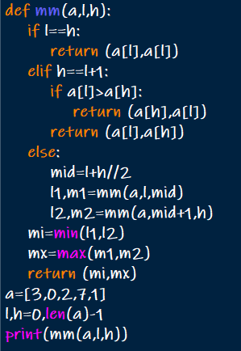

OUTPUT:



Merge sort

CODE:

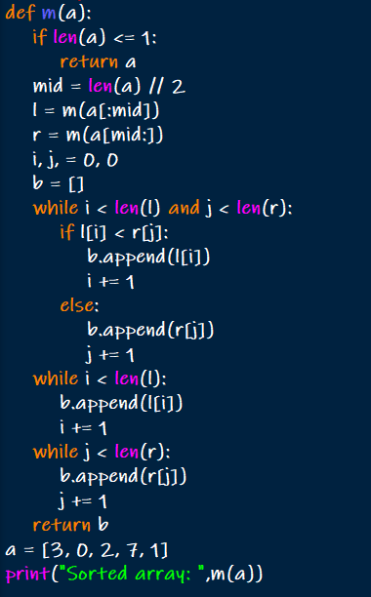

OUTPUT:



Quick sort

CODE:

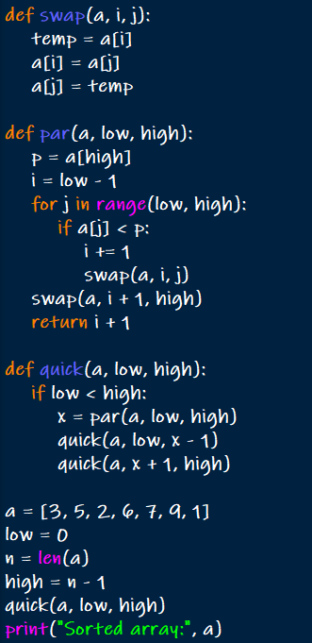

OUTPUT:



Binary search

CODE:

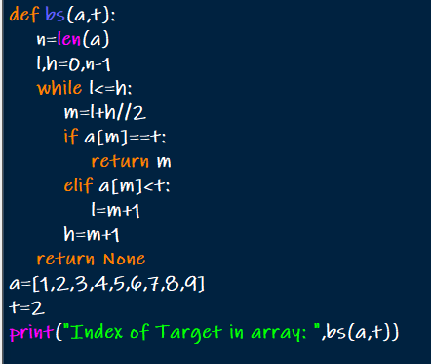

OUTPUT:



Strassens matrix multiplication

CODE:

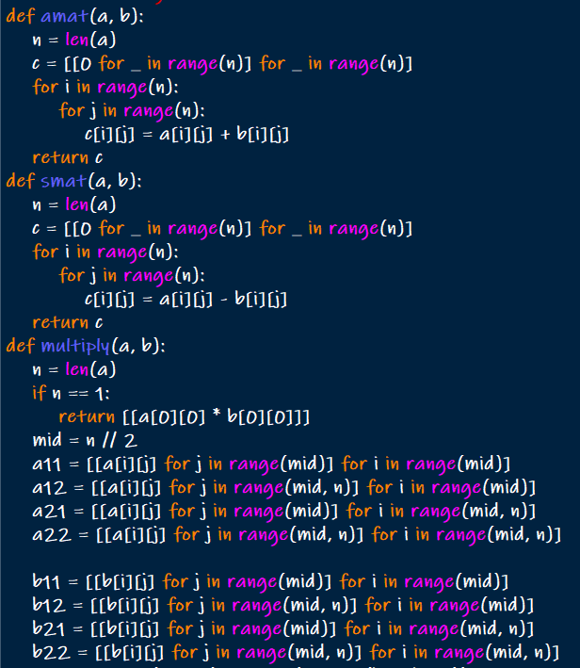

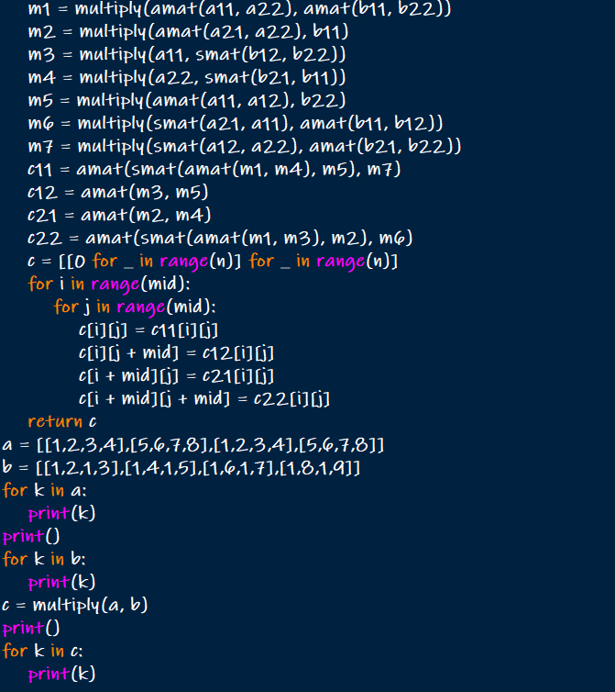

OUTPUT:

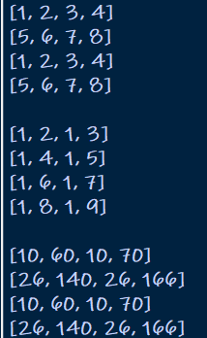

Karatsuba algorithm for multiplication

CODE:

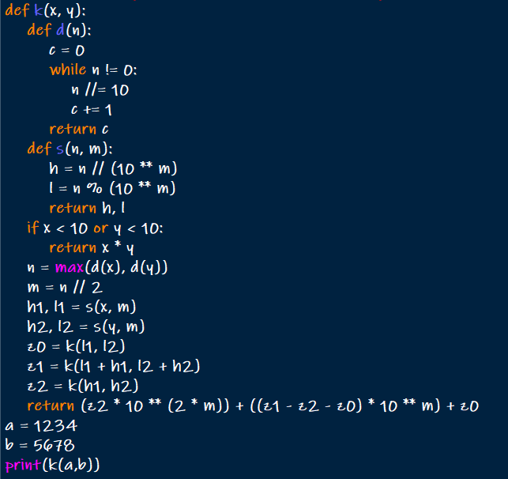

OUTPUT:



Closest pair of points using divide and conquer

CODE:

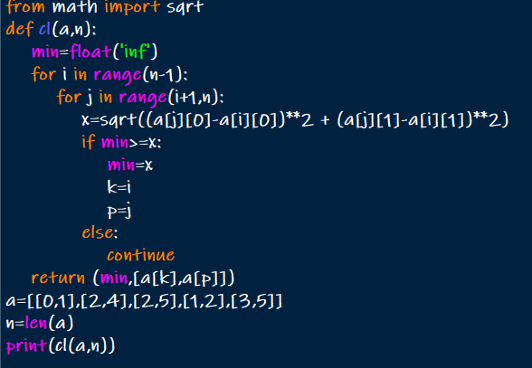

OUTPUT:



Median of medians

CODE:

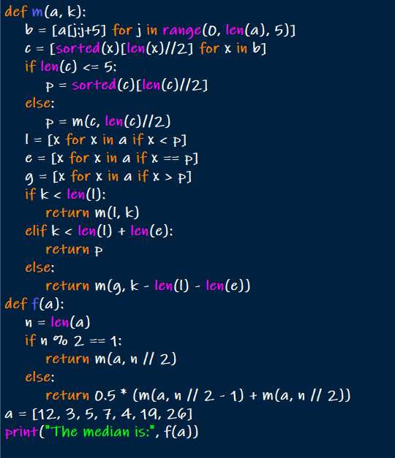

OUTPUT:



Meet in middle technique

CODE:

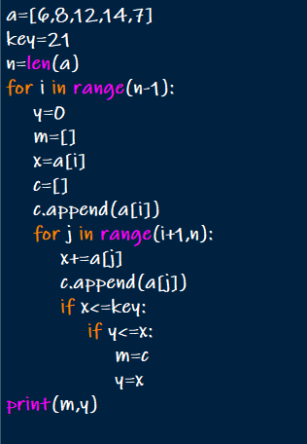

OUTPUT:

